**M_L Project Model Deployment**

**Link :-**

[**https://fuel-consumption-ratings.streamlit.app/#fuel-consumption-prediction**](https://fuel-consumption-ratings.streamlit.app/#fuel-consumption-prediction)

[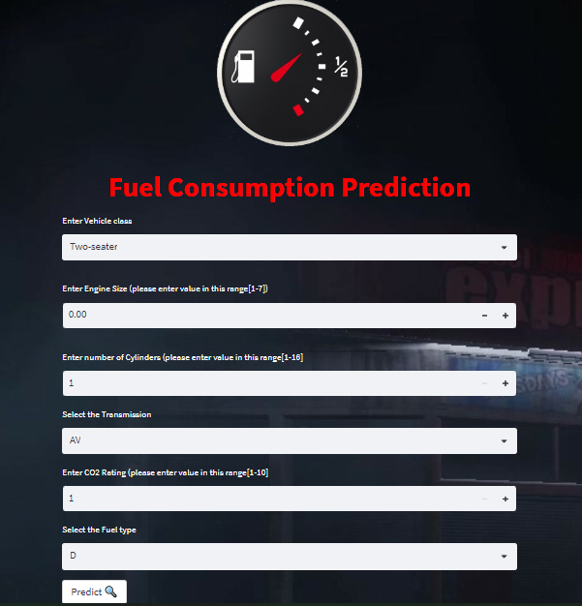](https://fuel-consumption-ratings.streamlit.app/#fuel-consumption-prediction)